**3. Requirement Analysis**

**3.4 Technology Stack (Architecture & Stack)**

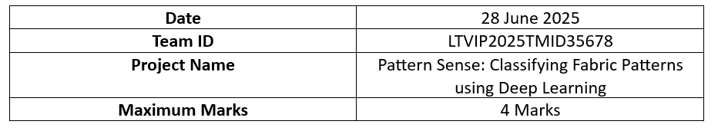

**Technical Architecture:**

The architecture of the Pattern Sense system is designed to allow users to upload images through a web interface, process the images via a trained CNN model, and display classification results (e.g., "Striped", "Polka-Dotted"). The architecture consists of the following components.

**Table-1: Components & Technologies:**

|  |  |  |  |
| --- | --- | --- | --- |
| **S. No** | **Component** | **Description** | **Technology** |
| 1 | **User Interface** | Web-based UI for users to upload fabric images and view predictions | HTML, CSS, JavaScript, Bootstrap |
| 2 | **Application Logic-1** | Logic to handle image upload and routing | Python (Flask Framework) |
| 3 | **Application Logic-2** | Preprocessing logic (resize, normalize) before model prediction | OpenCV, NumPy, Keras |
| 4 | **Application Logic-3** | Logic to call CNN model and get prediction output | TensorFlow / Keras |
| 5 | **Database** | Store image history and prediction logs (optional) | MySQL / SQLite |
| 6 | **Cloud Database** | Store large dataset or model logs in scalable storage (optional) | Google Cloud Firestore / Firebase Realtime DB |
| 7 | **File Storage** | To store uploaded fabric images temporarily | Local Filesystem / Firebase Storage |
| 8 | **External API-1** | Optional: Geolocation API to enhance UX (if used) | Google Maps API (optional) |
| 9 | **Machine Learning Model** | Classify uploaded fabric image into pattern classes | CNN (model_cnn.h5) built with Keras / TensorFlow |
| 10 | **Infrastructure** | Local Deployment via Flask / Colab / Hosting on Glitch or Render | Localhost (Flask), Google Colab, Render.com |

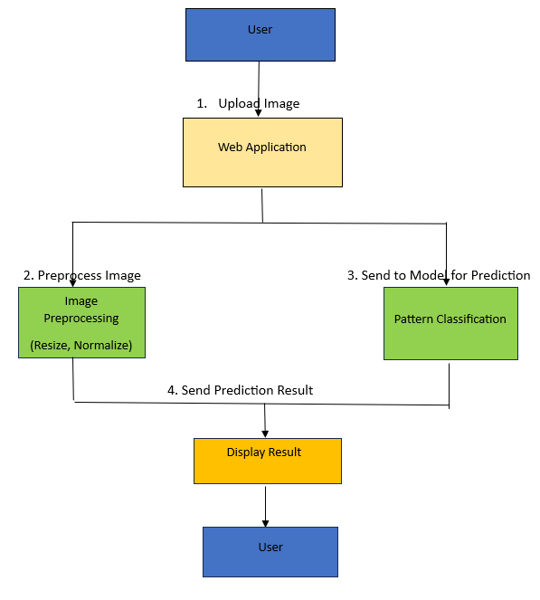

**Table 2: Application Characteristics**

|  |  |  |  |
| --- | --- | --- | --- |
| **S. No** | **Characteristic** | **Description** | **Technology Used** |
| 1 | Open-Source Frameworks | Use of open-source frameworks for development | Flask, TensorFlow, Keras, Bootstrap |
| 2 | Security Implementations | Secure upload path, file validation, HTTPS if hosted publicly | File type checking, Flask CORS, HTTPS |
| 3 | Scalable Architecture | System can be containerized or deployed to cloud platforms | Docker (optional), Render, Firebase |
| 4 | Performance Optimization | Preloading model, limiting file size, and image size for faster prediction | Image size thresholding, model caching |
| 5 | Availability | System hosted on local machine or public server for demo | Glitch / Render / Localhost |
| 6 | Maintainability | Easy-to-maintain codebase using modular Flask routes and clean UI | Flask blueprinting, template inheritance |

The Pattern Sense project is a deep learning-based image classification system developed to identify fabric patterns (e.g., Striped, Polka-Dotted, Plain, Checked) from uploaded images. The system is structured using a layered architecture to ensure modularity, performance, and scalability.

🧱 Architecture Overview

The application consists of three main layers:

1. Presentation Layer (Frontend/UI):
   * This layer provides the user interface for uploading fabric images and displaying the predicted result.
   * It is built using standard web technologies like HTML, CSS, and JavaScript with styling support from Bootstrap.
   * The interface is simple, intuitive, and responsive for both desktop and mobile users.
2. Application Logic Layer (Backend):
   * This layer handles HTTP requests, routes the image to the CNN model, and returns the prediction results to the frontend.
   * It is implemented using the Flask framework in Python, ensuring lightweight performance and easy integration.
   * The uploaded images are preprocessed (resized, normalized) using OpenCV and NumPy before classification.
3. Model & Storage Layer:
   * The core of the system is a trained Convolutional Neural Network (CNN) built using TensorFlow/Keras.
   * The model (model_cnn.h5) is responsible for identifying the fabric pattern based on the input image.
   * The system optionally stores uploaded images, prediction results, and logs using MySQL or SQLite for local development, and Firebase / Google Cloud Storage for cloud-based scaling.

🌐 External Integrations & Infrastructure

* The application can optionally integrate external APIs such as Google Maps (for geotagging images) or Feedback APIs.
* It is deployable on:
  + Local Systems using Flask
  + Cloud Platforms like Render, Firebase, or Google Colab for hosting and scalability.
* The system architecture is flexible and can be containerized using Docker for production-grade deployment.

🔒 Security & Maintainability

* The image uploads are validated (type/size) to prevent malicious file attacks.
* The backend uses Flask CORS and HTTPS (if cloud-hosted) to secure data flow.
* The system is built using open-source libraries and has a clean code structure, making it easily maintainable and extendable.

✅ Conclusion

The chosen technology stack ensures that Pattern Sense is:

* Easy to use
* Lightweight and responsive
* Modular and scalable
* Secure and adaptable for future extensions (like adding new pattern types or a mobile app)